A Case Study of Public Libraries in Ghana: Equipping Students with Critical Information Literacy Skills in the Age of AI and Misinformation
Ugne Lipeikaite
Public Library Innovation Programme, Electronic Information for Libraries, Santiago, Chile
E-mail address: ugne@eifl.net

Ramune Petuchovaite
Public Library Innovation Programme, Electronic Information for Libraries, Vilnius, Lithuania.
E-mail address: ramune@eifl.net

- Copyright © 2026 by Ugne Lipeikaite, Ramune Petuchovaite. This work is made available under the terms of the Creative Commons Attribution 4.0 International License: https://creativecommons.org/licenses/by/4.0/

Abstract:
Drawing on the practical experience of the “Digital Learning @ Ghana Public Libraries” project, this paper showcases how, despite their limited access to digital devices and connectivity, public libraries in Ghana successfully incorporated misinformation and AI literacy training into their digital and information literacy programmes for high school students. From 2024 to 2026, a partnership between the Ghana Library Authority (GhLA) and EIFL (Electronic Information for Libraries) implemented a project that reached over 22,100 students aged 12-18 through school outreach activities and in-library digital learning workshops at fifteen public libraries.
The project built the capacity of public library staff, equipping 30 regional and district librarians and ICT coordinators (digital learning facilitators) with the necessary skills, confidence, and resources to create effective learning experiences that differ from and supplement formal education. From the beginning, the project has focused on a hands-on, interactive, game-based learning approach in public libraries' information literacy programs. Instead of creating new resources, the project has adapted existing open educational resources for the target audience.
Initially, the libraries focused on providing practical digital and information literacy skills. Their educational ambitions evolved in response to the emerging challenges of misinformation and AI-generated content. For example, the EIFL compiled a training resource titled “Smart Use of Artificial Intelligence (AI).” Consequently, Ghanaian public libraries have expanded their information literacy programs to include an early understanding of misinformation and the ability to use AI while recognizing its potential risks. Post-training surveys of young learners, as well as feedback from library trainers, revealed that students demonstrated improved ability to assess the credibility of information, more responsible information sharing, and better search and research skills.

Keywords: Africa, Ghana, public libraries, AI literacy, open educational resources

Introduction: Project Aim and Partners
The Internet provides endless opportunities to support education, but access to ICT and digital skills training in Ghanaian schools is largely limited. In some cases, students can use the school's ICT laboratories once a week. However, there are often limited numbers of devices, as well as unstable power and internet connections. Some schools still lack any ICT infrastructure. As a result, millions of young people in Ghana lack the knowledge and skills needed to use the internet in meaningful ways - that, for example, would help them further their education or improve their chances of employment.
The "Digital Learning @ Ghana Public Libraries" project aims to create educational opportunities for 12 to 18-year-old students by advancing their ICT skills and engaging them in digital learning, based on free and open educational resources, through public libraries. It was successfully implemented in 2023-2026 by two partners: the EIFL (Electronic Information for Libraries) and Ghana Library Authority (GhLA).
EIFL (Electronic Information for Libraries) is an international nonprofit organization committed to improving access to knowledge in developing and transition economy countries through libraries and library consortia. The "Digital Learning @ Ghana Public Libraries" project was implemented through the EIFL Public Library Innovation Programme, EIFL-PLIP (Public Library Innovation Programme, n.d.). EIFL-PLIP aims to promote service innovation in public libraries by leveraging technology and the internet to provide communities with digital skills and access to relevant, up-to-date information, so that people can make informed decisions about education, employment, health, and other important areas of their lives.
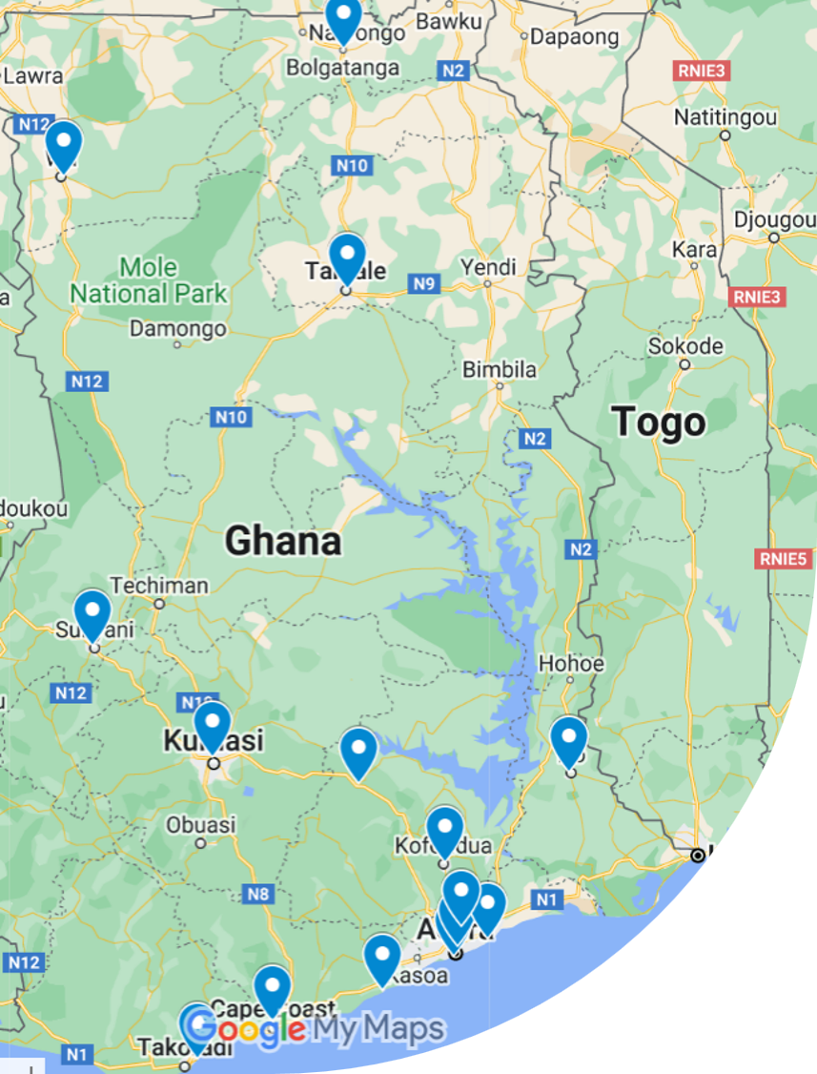
The Ghana Library Authority (GhLA) is a government agency under the Ministry of Education responsible for developing, coordinating, and managing public library services in Ghana. The GhLA's mission is to expand equitable and inclusive access to knowledge and provide vibrant, innovative, and digitally enabled spaces that support learning, culture, and community development for all. GhLA maintains a network of 142 regional and district libraries across all sixteen regions of Ghana, complemented by 11 mobile library vans that regularly run outreach services and community reading programmes to schools (Ghana Library Authority, 2026). Most GhLA public libraries provide public access to computers; around one-third also provide public access to the internet.
The "Digital Learning @ Ghana Public Libraries" project, launched in 2023 with fifteen public libraries across the country, marks a new phase in the long-standing collaboration between EIFL and GhLA (see map). Past collaborations include conducting the Public Library Perception Study (Perceptions of public libraries in Africa, 2011); providing advocacy training to improve ICT infrastructure; supporting pilot projects for innovative, ICT-based services at individual libraries; supporting the professional development of young public library innovators; and implementing the EIFL-PLIP national capacity-building initiative, which provided training to public librarians and front desk staff at 29 public libraries with computers and internet access (Capacity building of public librarians in Ghana, n.d.) As a result, GhLA library staff gained the capacity and confidence to integrate technology into their daily work and library services to benefit their communities. They established local partnerships to continuously develop services and improve the ICT infrastructure of the GhLA public library network (Lipeikaite et al, 2024).
Overall Results and How the Project Got There
From September 2023 to May 2026, the Digital Learning @ Ghana Public Libraries project has built the capacity of 30 librarians and ICT coordinators at 15 regional and district public libraries to organize and deliver digital and information literacy (DIL) skills classes in schools and in-depth digital learning workshops in libraries.
Through outreach visits to schools, the project reached over 19,800 students from more than 300 Junior and Senior High Schools. In addition, over 2,300 students completed in-depth digital learning workshops delivered in libraries. In total, the project directly benefited more than 22,100 students (Digital Learning @ Ghana Public Libraries, 2023-2026).
The project introduced students to a wide range of topics, including basic ICT skills, Microsoft Office, internet search, digital reading, online safety, coding, graphic design, and web development. Library staff shared that during training activities, students often reported frequent exposure to risks such as unwanted messages on social media, cyberbullying, and misleading or manipulative content on platforms like YouTube and Facebook. To ensure active participation and practical learning, library staff used interactive and learner-centered methods such as hands-on exercises, Kahoot quizzes, gamification, group activities, roleplay, videos, and demonstrations.
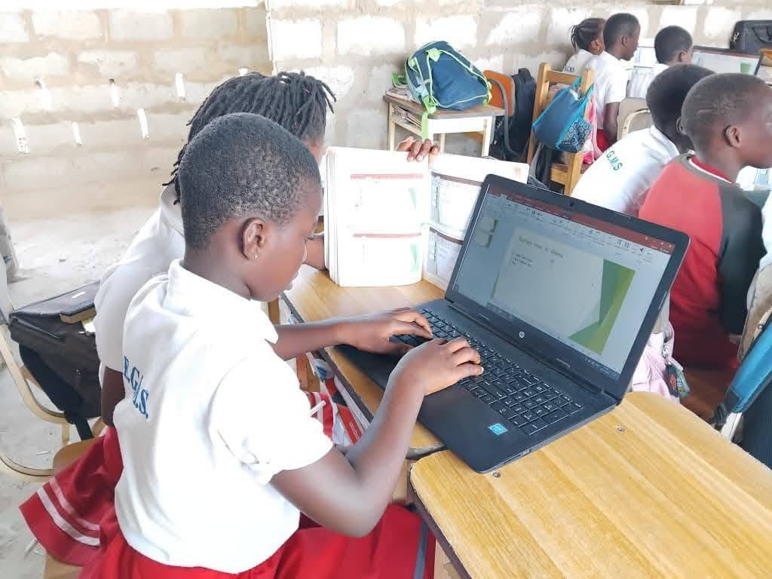
GhLA Photo: Effutu Municipal Library's outreach visit to a school in Ghana's Central Region.
From the beginning, the "Digital Learning @ Ghana Public Libraries" project has focused on a hands-on, interactive, game-based learning approach in public libraries' information literacy programs for students. Instead of creating new training and learning resources, the project has used a strategy of researching, selecting and, often, adapting existing open educational resources (OER) for the target audience - 12 to 18 year old school students.
Librarians and ICT coordinators, who were selected to become digital learning facilitators for students, went through a 2-week face-to-face training of trainers programme, which included building their facilitation abilities, digital and mobile information literacy, selection and adaptation of relevant OER for library training, and online privacy and safety.

Librarians have embraced the idea of digital learning based on OERs and seamlessly adopted it for two main project activities: short, mobile classes for students during outreach visits to schools and in-depth, four- to six-week-long digital learning workshops for students organized in libraries.

Integrating Open Educational Resources (OERs) into Library Digital and Information Literacy Programmes
At the beginning of the project, the EIFL-PLIP and GhLA teams compiled a preliminary list of relevant open educational resources (OER) for students. The final selection of OERs used in library training activities was made based on the needs assessment study conducted by the fifteen public libraries that were part of the project. It aimed to better understand the current state of digital skills, identify existing gaps, and gather recommendations on topics to be included in the project's training curriculum.
In early 2024, public library staff conducted interviews with key stakeholders, including 106 students and ICT teachers from 70 Ghanaian schools. The findings confirmed a strong interest in practical ICT skills, effective internet searching, mobile phone use, coding, and digital reading. The interviews also revealed that most students had only basic digital skills, such as typing on a keyboard and using a computer mouse. Their use of the internet was largely limited to communication and entertainment, including messaging, short videos, and social media. Teachers expressed particular concern about online safety, while the findings highlighted students' limited awareness of online risks and a lack of understanding of how the internet could be used to support learning.
The needs assessment informed both the project’s training of trainers programme aimed at library staff and the subsequent outreach and in-library digital learning activities delivered to students. However, online educational content developed in Ghana for the project's target group (students aged 12–18) was scarce. As a result, we researched and selected relevant OERs from other countries in Africa and beyond. For information literacy training for 12-18 year olds, Ghanaian librarians primarily relied on resources such as:
“Internet Basics” – an online course available on the DigitalLearn.org platform that introduces new internet users to basic terminology, browser navigation, search engines, and websites (Internet Basics, 2017).
“Super Searchers” – a global information and digital literacy programme developed by Google specifically for libraries. The programme teaches learners how to find reliable information online, verify facts, identify scams, and critically evaluate search results, including those generated by AI-powered tools (Super Searchers, 2025).
“Digital Enquirer Kit” – a free online course developed by Tactical Tech that helps learners to develop media literacy skills, identify misinformation, verify online information safely, and protect their digital devices (Digital Enquirer Kit, 2021).
As these OERs were developed in contexts very different from Ghana, librarians and ICT coordinators adapted and localized portions of the content before introducing it to students. For example, the Upper East Regional Library worked collaboratively to localize the “Internet Basics” course from “DigitalLearn.org” platform, which is an online hub for digital literacy training developed by the Public Library Association, a division of the American Library Association. Examples, exercises, and practical activities were adapted to reflect local realities and make the content more relevant to Ghanaian learners.
Together, these OERs supported the development of key DIL competencies (searching, evaluating, verifying, and using information) among young learners. “Internet Basics” introduces students to navigating the online information environment and understanding how websites and search engines work. “Super Searchers” strengthens their ability to locate, evaluate, and verify information from online sources, while “Digital Enquirer Kit” helps learners critically assess online content, identify misinformation, and develop safe information practices.
Adapting OERs for AI and Misinformation Education
As the project progressed successfully, the educational ambitions of Ghanaian libraries expanded to address new challenges that emerged, including growing concerns about misinformation and AI-generated content. We looked for more OERs that dealt with these new issues and then worked with African librarians to adapt them.
One example is the offline escape-room-style game “Mission Viral”, designed to help young people understand misinformation, deepfakes, and AI-generated content. The game was originally developed by the Center for an Informed Public at the University of Washington (UWCIP). A joint team consisting of Ghanaian public librarians, experts from the EIFL-PLIP, and UWCIP collaborated to adapt and localize the game for the Ghanaian context (Mission Viral, 2025).
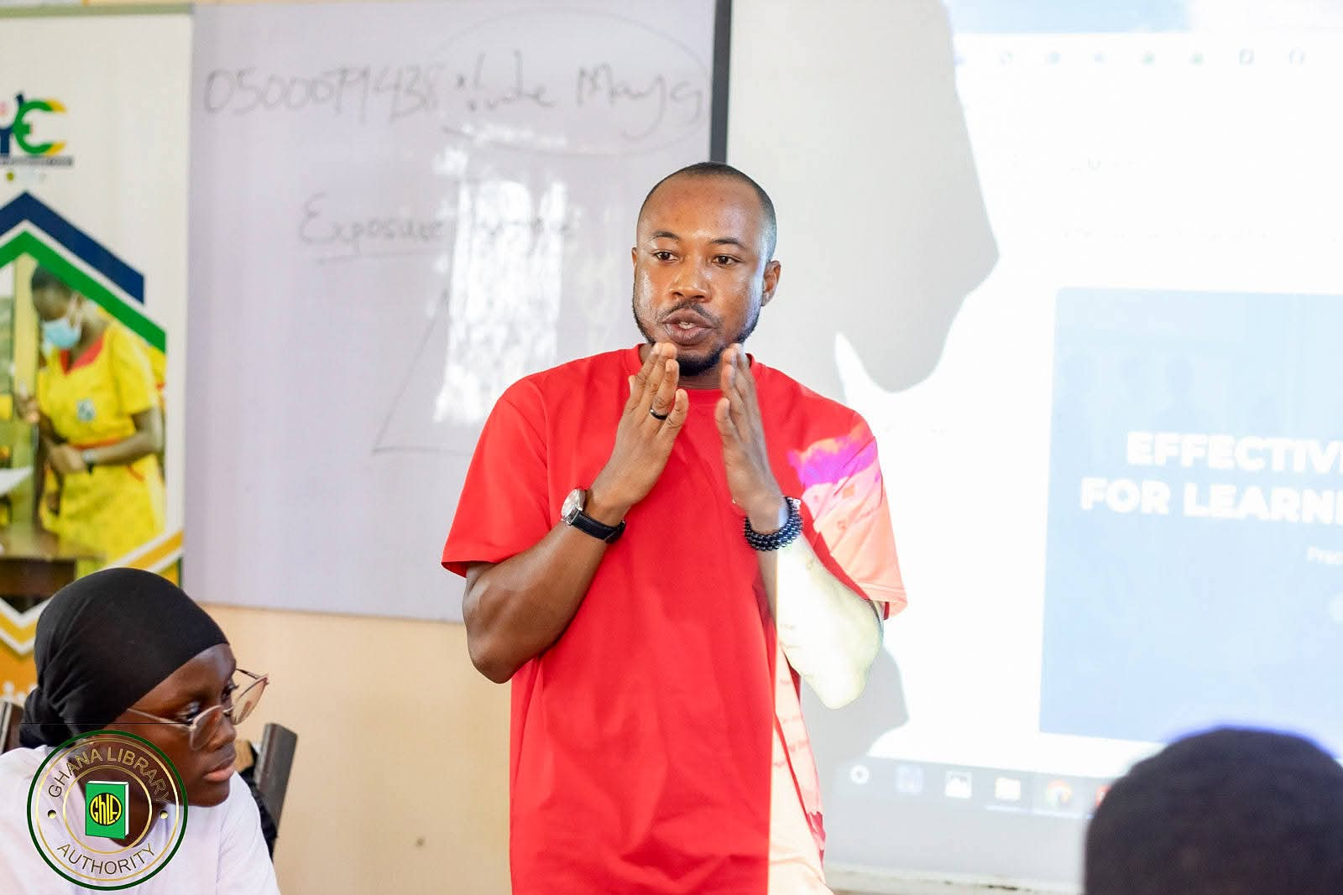
The co-creation process began with an introductory in-person meeting in Accra, Ghana, followed by five online workshops. During these sessions, the team explored the local misinformation landscape and discussed the challenges faced by young people in Ghana. Together, they defined the target audience, learning objectives, and game setting; developed the storyline; and created an initial prototype. The prototype was printed and distributed to participating libraries, where it was tested with small groups of young people. Feedback from these pilot sessions informed the final revisions. The completed game is now available online for free through the Loki's Loop platform (Lokis Loop, 2020). All fifteen libraries that participated in the “Digital Learning @ Ghana public libraries” project, as well as other interested institutions, are set to receive copies that are currently being printed and distributed by GhLA. Also, a researcher from the University of Washington is going to Ghana to observe how the game is used in selected libraries for evaluation and further research.

GhLA Photo: Prince Osei-Gyamfi, ICT coordinator at the Central Regional Library in Cape Coast, teaches students how to use AI for learning.
Additionally, based on other UWCIP materials, Ugnė Lipeikaitė - the Impact Manager of EIFL-PLIP and one of this paper's authors - developed facilitator guides and presentations “Smart Use of Artificial Intelligence (AI)” (Smart Use of Artificial Intelligence, 2026) and “Navigating the Truth: Understanding Misinformation” (Navigating the Truth, 2025). These training resources draw on educational approaches pioneered by UWCIP and were further enriched through contributions from experienced public library trainers in Ghana, Kenya, and South Africa to ensure their relevance for African communities.
These resources allowed Ghanaian public librarians to further expand students' DIL competencies beyond the basics, supporting the development of critical thinking, information evaluation, and responsible participation in the digital world. Students learned how information can be manipulated, how AI-generated content is created, and how to evaluate the reliability of digital information.
What are the Outcomes and Impact?
Since the project aimed to introduce students to digital learning opportunities by advancing their ICT skills, the evaluation framework primarily focused on their practical digital literacy. The library staff leading the digital learning workshops were provided with a Kobo Tools reporting form and a Google Forms questionnaire for the participants to complete after the training. From May 2024 to May 2026, a total of 517 young learners participated in the post-training survey, self-assessing their knowledge and skills in the training area before and after the workshop.
The survey results indicate a significant impact on learners' confidence and willingness to engage with technology. Ninety-six per cent reported increased confidence in using the internet and digital devices. Many participants explained that, before joining the library training, they were hesitant to use technology independently. However, through practical activities and supportive facilitation, they became more comfortable experimenting with digital tools and using them for learning. Teachers also observed positive changes in students' engagement and motivation.
The post-training survey also provides evidence of improvements in information literacy, especially with regard to finding, evaluating, using, and sharing information online. Of the 517 post-training survey respondents, 112 were participants in digital learning workshops that covered information literacy topics such as online searching, evaluating online information, misinformation, and AI-generated content.
Among these 112 learners, 60% reported having very little or no prior knowledge of these topics before the training. After completing the workshops, 96% reported gaining some knowledge or a lot of knowledge. Overall, 97% of participants reported having at least some knowledge of online searching and information evaluation after the training, while only 3% still reported very limited knowledge (see the diagrams below).
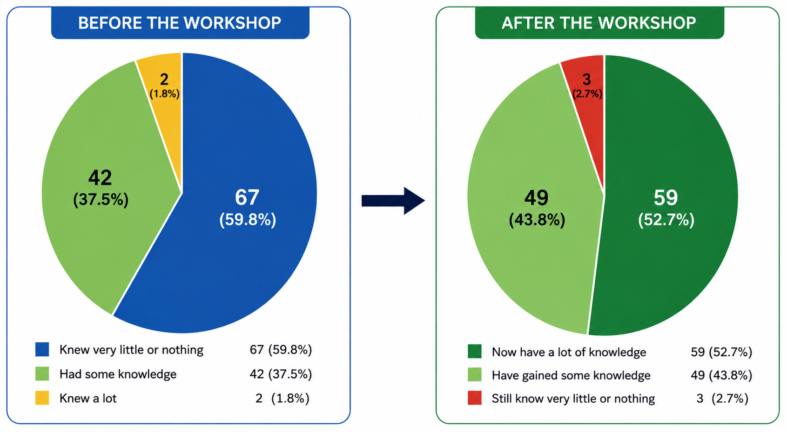
Diagram: Participants’ knowledge of online searching and evaluation before and after digital learning workshops
Beyond knowledge gains, participants also reported applying their information literacy skills in practical ways. Many described using the Internet more effectively for school assignments, conducting online research, accessing educational resources, and verifying information. Some participants reported sharing these skills with family members and peers, demonstrating that the benefits of the training extended beyond individual learners and contributed to broader digital and information literacy within their communities. These examples suggest that participants were not only acquiring knowledge but also developing the confidence and critical thinking skills needed to use information effectively in their daily lives:
“What I learnt at the library has helped me in many ways. For instance, I can now tell whether information is real or fake.”
— Participant, Digital Learning Workshop, Cape Coast Public Library
“Learning in the library has helped me complete most of my assignments in a short period of time because the skills I learnt help me to research information on the Internet.”
— Participant, Digital Learning Workshop, Eastern Regional Library
“I am now using the Internet to research information for school assignments and access online educational resources.”
— Participant, Digital Learning Workshop, Central Regional Library
These findings suggest that the fifteen public libraries in Ghana that participated in the "Digital Learning @ Ghana Public Libraries" project played a significant role in enhancing the DIL skills of young individuals. Notably, in addition to supplementing the ICT curriculum, the libraries addressed the limited access to ICT devices and the internet in schools. Skilled library staff helped learners develop the competence and confidence needed to search for, evaluate, and use information more effectively in an increasingly complex digital environment by combining adapted Open Educational Resources (OER), practical learning activities, library public access computers, and connectivity.
The impact in Ghana can be expanded by experienced digital learning facilitators sharing best practices and resources with their peers when more public libraries are equipped with public access computers and reliable (always-on) internet.

Acknowledgments
The authors would like to express their special appreciation to the public libraries and digital learning facilitators in Ghana for their hard work and creativity in providing training to students and collecting the data on which this case study is based. We would also like to thank the Ghana Library Authority project team for their long-standing collaboration and contribution to the project's success.

References

Capacity building of public librarians in Ghana (n.d.). EIFL. https://www.eifl.org/eifl-in-action/capacity-building-public-librarians-ghana
Digital Enquirer Kit. (2021). Tactical Tech. https://digitalenquirer.org/
Digital Learning @ Ghana Public Libraries (20023-2026). EIFL. https://eifl.net/eifl-in-action/digital-learning-ghana-public-libraries
Ghana Library Authority (GhLA) (2026). Strategic Plan 2026 – 2035: Transforming Libraries, Empowering Communities, Building a Knowledge-Driven Ghana. 47 p.
Internet Basics (2017). DigitalLearn.org. The Public Library Association https://training.digitallearn.org/courses/internet-basics-new
Lipeikaite, Ugne, & Petuchovaite, Ramune (2024). Gearing up public librarians for the mission of digital inclusion of all: EIFL case studies from Uganda and Ghana [Conference presentation]. 3rd International Conference on Information Literacy (ICIL-Africa 2024, 14-17 October 2024), Alexandria, Egypt. EIFL. https://eifl.net/resources/gearing-public-librarians-mission-digital-inclusion-all-eifl-case-studies-uganda-and-0
Lokis Loop: Games and play-based activities (2020). The Centre for an Informed Public at the University of Washington. https://lokisloop.org/games/
Mission Viral (2025). Created in collaboration with EIFL and Ghana Library Authority. Lokis Loop. Center for an Informed Public, University of Washington. https://lokisloop.org/en-mission-viral/
Navigating the Truth: Understanding Misinformation. (2025). PowerPoint presentation compiled by Ugnė Lipeikaitė, EIFL. https://www.eifl.net/resources/navigating-truth-understanding-misinformation-presentation-public-library-trainers-use
Perceptions of public libraries in Africa. (2011). EIFL. https://www.eifl.net/resources/perceptions-public-libraries-africa-0
Public Library Innovation Programme: Advancing Community Development (n.d.). EIFL. https://www.eifl.net/programmes/public-library-innovation-programme
Smart Use of Artificial Intelligence (AI). (2026). PowerPoint Presentation compiled by Ugnė Lipeikaitė, EIFL. https://www.eifl.net/resources/smart-use-artificial-intelligence-ai-presentation-public-library-trainers-use-ai-literacy
Super Searchers & Meet LEO. (2025). Created by Google and the Public Library Association. American Library Association. https://www.ala.org/pla/initiatives/informationliteracy/supersearchers

