EIFL ANNUAL REPORT 2016

Case Study Botswana

CASE STUDY - GORATA MATOME
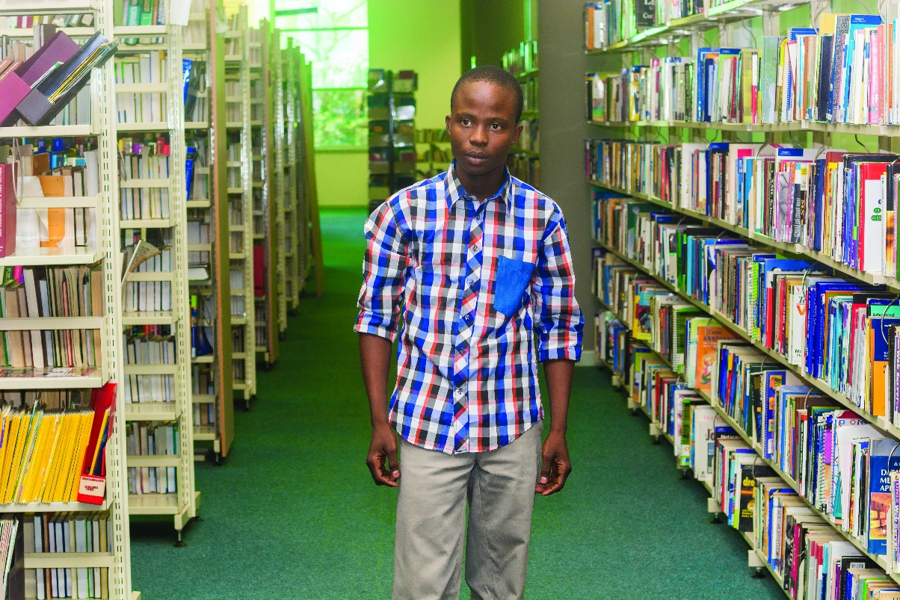
Student, University of Botswana, Gaborone
One day, when he was 15, Gorata Matome woke up to find a large dark spot in his vision. “From that day forward, I was partially sighted,” he said.
Today, aged 22, he is a third-year student of Environmental Studies and English at Botswana University. Studying is a struggle, because the library has very few books in accessible formats like braille, large print or audio. “I rely on librarians and friends to read books and articles for me,” he said.
But the future looks bright. In 2016 the Marrakesh Treaty entered into force, and Botswana was among the first 25 countries to ratify the Treaty. The Treaty gives organizations like libraries the right to reproduce printed works in accessible formats and to exchange these works across national borders. EIFL has been a strong advocate for ratification of the Marrakesh Treaty and its implementation into national law.
Once the Treaty has been implemented into Botswana’s copyright law, blind and visually impaired people will have access to thousands more books.
“The Treaty will help all visually impaired people – starting from primary, junior and senior schools. We will be able to compete equally with people who can see, and many more of us will be able to enter professions like law and medicine,” said Gorata.
Quote from Gorata Matome:
“I will be able to satisfy my thirst for knowledge and at last I will be able to study and research independently!

