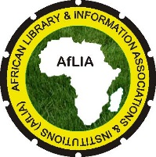
African Library and Information Associations and Institutions (AfLIA)
Association Africaine des Bibliothèques et des Institutions d’Information
Associação de Bibliotecas e Instituições de Informação

AfLIA 2015 CONFERENCE & 3RD AFRICAN LIBRARY SUMMIT
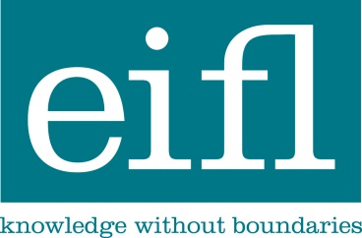

POST-CONFERENCE
“AFRICAN PUBLIC LIBRARIES ON THE RISE: SERVICE INNOVATION FOR COMMUNITY DEVELOPMENT”

Venue: GIMPA Conference Centre, Accra, Ghana
DATE: 3rd June 2015
PRELIMINARY AGENDA

Time | Session
8.00-9.00 | Registration
9.00-9.30 | Welcome and opening session – Moderator – Ramune Petuchovaite – EIFL Public Library Innovation Programme (EIFL-PLIP)  - Deborah Jacobs – Global Libraries, Bill and Melinda Gates Foundation  - D. Helena Asamoah-Hassan – AfLIA  - Ofosu Tenkorang – Ghana Library Authority
9.30-10.45 | Plenary session – Moderator – Dr Buhle Mbambo-Thata – UNISA library, AfLIA  - Mark West – UNESCO – Literacy and learning in mobile era  - Joan Mwach – Worldreader: Delivering Impact through Libraries, e-Reading, Activities and Partnership  - Eliphas Nyamogo – Goethe-institut Kenya – Library Awards as a Catalyst for Excellence in Library Services: A Case Study of the Maktaba Awards in Kenya  - Ramune Petuchovaite, Ugne Lipeikaite – EIFL-PLIP: Public libraries service innovation advancing community development
10.30-11.00 | Tea break
11.00-13.00 | Panel session 1: Innovative public library services in Africa – Moderator – Deborah Jacobs – Global Libraries, Bill and Melinda Gates Foundation  Showcasing the technology based service innovation addressing needs of different groups (~45 min)  - Nyasha Sithole – Masiphumelele Public Pibrary, South Africa  - Asia Kamukama – Maendeleo Foundation, Uganda  - Aaron Kuwornu – Northern Regional Library / Ghana Library Authority  - Mary Kinyanjui – Kibera Community Library / Kenya National Library Service  - Alikem Tamakloe – Volta Regional Library/ Ghana Library Authority  - Richard Aoko Oketch – Dr Robert Ouko Memorial Community Library / Kenya National Library Service  Round table discussions (~1 hour)
13.00-14.00 | Lunch
14.00-16.00 | Panel session 2: Public librarians’ capacity building in Africa – Moderator Dr. Perpetua Dadzie, Ghana University  Sharing experience on public librarians’ capacity building structures, strategies and practices to support service innovation (45 min)  - Gertrude Kyaga Mulindwa – National Library of Uganda  - Richard Atuti, Director – Kenya National Library Service  - Dr. Victoria Okojie – Librarians’ Registration Council of Nigeria  - Guy Amarteifio – Greater Accra Regional Library, Ghana / Ghana Library Authority  - Magdaline Mooketsi – Molalatau Community Library & Cultural Centre, Botswana  - Darren Hoerner – Global Libraries, Bill and Melinda Gates Foundation  Round table discussions (~1 hour)
16.00-16.30 | Closing session – Moderator – (tbi)  Summarizing the post-conference discussions and sharing recommendations  Closing remarks – Ramune Petuchovaite – EIFL-PLIP
16.30-17.00 | Tea discussions and farewell

